**Image Generation using stable diffusion & Comfy UI**

A Project Report

submitted in partial fulfillment of the requirements

of

AICTE Internship on AI: Transformative Learning

with

TechSaksham – A joint CSR initiative of Microsoft & SAP

by

**Tattukuri Jaswanth**

**jaswanthtattukuri@gmail.com**

Under the Guidance of

**Pavan sumohana**

**ACKNOWLEDGEMENT**

I would like to take this opportunity to express my sincere gratitude to everyone who has supported me throughout the course of this thesis project.

First and foremost, I extend my deepest appreciation to my supervisor, **Pavan Sumohana Sir**, for his unwavering guidance and mentorship. His invaluable advice, continuous encouragement, and constructive feedback have played a pivotal role in shaping this project. The trust and confidence he placed in me served as a significant source of motivation throughout my research journey. Working under his supervision over the past year has been an enriching experience, offering not only academic and technical insights but also professional and personal growth. His unwavering support, both in the project and throughout various aspects of the program, has been truly inspiring, and I am immensely grateful for the opportunity to learn from him.

I would also like to extend my gratitude to **Edunet** for their insightful suggestions and constructive feedback, which significantly contributed to enhancing the quality of this work. Their valuable input played a crucial role in the successful completion of this project.

Finally, I am thankful to my peers, family, and friends for their continuous support and encouragement throughout this journey.

#### **ABSTRACT**

This explores the transformative potential of **artificial intelligence (AI) in the field of creative learning**, with a particular focus on **image generation using Stable Diffusion and ComfyUI**. The core objective of this research is to examine how AI-driven tools, such as Stable Diffusion, can enhance creative processes and pave new pathways for automated image generation. This study delves into the underlying mechanisms of Stable Diffusion—one of the most advanced deep learning models for generating image data from textual prompts—and investigates how ComfyUI simplifies user interaction with these complex AI systems.

The research methodology employed **case studies and practical experiments** to evaluate the capabilities, limitations, and user experience of AI-based image generation tools. The findings demonstrate that Stable Diffusion is highly effective in generating high-quality and diverse images based on various user inputs. Additionally, ComfyUI significantly improves accessibility by offering a more intuitive and user-friendly interface, even for technically complex AI services.

The study highlights the **growing role of AI in creative industries**, emphasizing its applications in **art, design, and education**. By examining the challenges and opportunities associated with AI adoption, this research contributes to the broader discourse on AI’s role in creative processes. Furthermore, it addresses **ethical considerations** surrounding AI-generated imagery and explores potential future developments in the field.

In conclusion, this thesis underscores **AI’s transformative impact on creative learning** and provides a comprehensive analysis of how Stable Diffusion and ComfyUI function in practical scenarios. It also identifies key limitations in AI-driven image generation, laying the foundation for further research and advancements in this domain.

**TABLE OF CONTENT**

**Abstract I**

**Chapter 1.**  **Introduction 1**

1.1 Problem Statement 1

1.2 Motivation 1

1.3 Objectives 1

1.4. Scope of the Project 2

**Chapter 2.**  **Literature Survey 3**

**Chapter 3.**  **Proposed Methodology 6**

**Chapter 4.**  **Implementation and Results 9**

**Chapter 5. Discussion and Conclusion 14**

**References** 18

**LIST OF FIGURES**

|  |  |  |
| --- | --- | --- |
| **Figure No.** | **Figure Caption** | **Page No.** |
|  | **System Design Diagram of the Proposed Solution** | **6** |
|  | **Snapshot of the Loding the image** | **9** |
|  | **Snapshot of the Detecting edges using Canny Edge** | **10** |
|  | **Snapshot of the Loading the model to extract poses** | **11** |
|  | **Snapshot of the Loading the ControlNet model** | **12** |
|  | **Snapshot of the Generating images using poses** | **13** |

**CHAPTER 1**

**Introduction**

* 1. **Problem Statement:**

It pertains to AI-generated images- how complex is this, to which extent will the complexity prohibit the access that a normal and even an aspiring person might receive from it especially for Stable Diffusion. An AI model of Stable Diffusion does have huge power in allowing images to generate out of just texts but may limit the general access due to the complexity imposed. The problem lies in the fact that these tools need to be made usable by a wider population of users who don't necessarily have technical backgrounds, and the way they interact with these advanced AI systems should be easier. The challenges identified here are significant because AI-driven creativity is transformative in industries like art, design, marketing, and education but does not realize its full potential without an easy-to-use interface.

* 1. **Motivation:**

This project was chosen to fill the gap between advanced AI image generation technologies and the everyday user. As generative models like Stable Diffusion continue to shape creative industries, making these tools more accessible could democratize creativity, allowing individuals from various fields to produce high-quality visual content without needing specialized knowledge. This has the potential to be used in a variety of applications, such as creating art, educational content, marketing campaigns, game design, and social media content generation. The project will help empower more people to use AI for creative purposes, thereby increasing the reach and impact of AI-driven tools in the digital creative economy.

* 1. **Objective:**

The main goals of this project are as follows:

* Explore the capabilities of Stable Diffusion in generating high-quality images from textual prompts.
* To investigate whether the friendly interface, like Comfy UI, makes it easier for non-expert users to interact with Stable Diffusion.
* Evaluate the usability, accessibility, and potential of AI-driven image generation tools for creative use.
* Provide an overview of challenges and opportunities with the integration of AI into creative workflows, and especially for the non-technical user.
  1. **Scope of the Project:**

This project focuses on the unification of Stable Diffusion with Comfy UI to understand how AI-powered image generation may be adapted into user-friendly interfaces for non-tech users. The scope includes evaluating Stable Diffusion's capacities, testing Comfy UI as a solution for simplifying user interaction, and analyzing the potential applications of AI-powered images in the creative industries. The limitations of this project include

* The focus solely on one AI model - Stable Diffusion - and one user interface - Comfy UI.
* It doesn't focus on the technical implementation or deep development of AI models but on user experience and accessibility aspects.
* The study is confined to the applications in creative fields and does not explore other potential uses of AI image generation.

**CHAPTER 2**

**Literature Survey**

* 1. **Review relevant literature or previous work in this domain.**

**The field of AI-driven image generation has accelerated rapidly over the last few years, with massive strides in deep learning and generative models. Early methods of image generation, like Generative Adversarial Networks (GANs), have formed the base for modern AI art. Goodfellow et al. (2014) proposed GANs as a means of creating realistic images through training two neural networks against each other. However, the intricacy and computationally expensive process of training these models made it difficult for such models to be accessible to regular users.**

**Denoising diffusion probabilistic models (DDPM) have lately become a strong alternative, of which Stable Diffusion is among the most effective. These models can generate images from text in a more controlled and efficient way. Recent studies, for example, by Ramesh et al. (2021) and the developers of Stable Diffusion, have demonstrated that such models are capable of generating high-quality images from natural language input. While these models are powerful, they are still too complex for many non-technical users.**

**Several user interfaces and tools, like DreamStudio and Comfy UI, have sought to make this easier by making these models as easy to use as possible by offering intuitive GUIs for the generation of images. However, usability, accessibility, and performance differ across all of these tools, and making AI image generation technologies accessible to the general public remains an open challenge.**

* 1. **Mention any existing models, techniques, or methodologies related to the problem.**

**Relevance of Techniques and Models Relevant to this Project on AI-driven Image Generation:**

* **Generative Adversarial Networks (GANs): This is one of the foundational techniques in generative AI, whereby a generator network constructs images, while a discriminator network estimates how realistic they are. Although GANs have led to impressive art generation, they also require high computational power resources and lack interpretability compared to newer models such as diffusion models.**
* **Denoising Diffusion Probabilistic Models (DDPM): Stable Diffusion is based on DDPMs, which iteratively transform random noise into a coherent image. This method has proven to be more stable and controllable compared to GANs, especially in generating high-quality images from text prompts.**
* **Stable Diffusion This is perhaps a state-of-the-art model about text to an image diffusers. One reason it made fame is through this open source with which now several communities utilize to create even simple images just described in pure written language and high-quality in varied diversity using mass amounts of denoising processes.**
* **Comfy UI: Comfy UI is a friendly interface that's designed to be user-friendly so that one can interact with the complex models such as Stable Diffusion. This is supposed to make the very advanced AI tools more accessible, abstracting much of the technical complexity away so that people without much technical knowledge can produce really high-quality images.**

**These models and tools collectively represent the pool of AI-generated imagery. Stable Diffusion is one such tool that has proven to be powerful yet is growing in popularity. However, many users often find these tools difficult to use without appropriate technical knowledge.**

* 1. **Highlight the gaps or limitations in existing solutions and how your project will address them.**

**While Stable Diffusion and other generative models represent significant advancements in AI image generation, several gaps remain:**

* **Complexity and Accessibility: Even though the tools, such as Stable Diffusion, are very powerful, they are hard to use for non-expert users. The process of running these models often requires technical skills, including setting up Python environments, managing dependencies, and understanding machine learning concepts. Most current user interfaces still require some familiarity with the technical aspects of the model.**
* **Usability Issues: While Comfy UI and other tools have helped in making the interactions more simple, the interfaces are not yet intuitive for all, especially those not familiar with AI. The absence of standard design patterns and accessibility features makes it even worse for the user.**
* **Ethical and Legal Concerns: The creative potential of AI models raises ethical issues, such as the use of copyrighted data in training, the possibility of generating harmful or biased content, and questions of ownership of AI-generated art. Current models still face challenges in addressing these ethical concerns effectively.**
* **How Your Project Will Address These Gaps: This project will address the identified gaps by**
* **Improving accessibility by focusing on an intuitive, easy-to-navigate interface, such as Comfy UI, and ensuring that non-technical users can leverage the power of Stable Diffusion without prior knowledge of machine learning.**
* **Evaluating the performance of user interfaces, such as Comfy UI, in terms of ease of use, providing feedback on how these tools can be improved to meet the needs of the broader public.**

**This research aims at exploring ethical issues and possible ways of responsible use in creative industries. This also includes content filtering mechanisms and informing users of proper ethical use through AI-generated images.**

**By closing these gaps, this project aspires to extend the accessibility of AI-driven image generation to wider audiences, contributing to creativity and innovation across multiple sectors.**

**CHAPTER 3**

**Proposed Methodology**

* 1. **System Design**

The proposed solution aims to provide an accessible and intuitive interface for generating images using Stable Diffusion, enabling non-technical users to create high-quality images from textual descriptions. The system integrates **Stable Diffusion**, an AI model for text-to-image generation, with **Comfy UI**, a user-friendly graphical interface designed to simplify user interaction with this complex technology.

**Diagram of the Proposed Solution:**

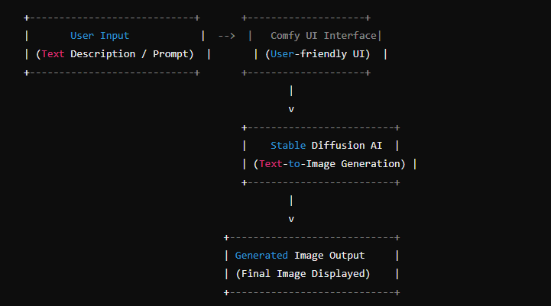**Explanation of the Diagram:**

* **User Input (Text Description/Prompt):** The user provides a textual description or prompt to generate an image. This can be a simple or detailed prompt, depending on the user's creative goals. Examples might include "a sunset over the mountains" or "a futuristic cityscape at night."
* **Comfy UI Interface:** Comfy UI is a graphical interface designed to simplify user interaction with Stable Diffusion. It takes the user’s input and handles the communication with the Stable Diffusion model. The UI abstracts the technical complexity, offering a clean, easy-to-use interface that guides the user through the process of generating images.
* **Stable Diffusion AI Model:** Once the prompt is received from the UI, it is passed to the Stable Diffusion model, which processes the text input and generates an image based on the prompt. Stable Diffusion uses a denoising diffusion process to iteratively convert random noise into a detailed image that reflects the input description.
* **Generated Image Output:** The final image, generated by Stable Diffusion, is displayed in the Comfy UI interface, where the user can view, modify, and save the output. Users may have the option to tweak parameters, refine their prompt, or generate multiple variations of the image.

This system design illustrates the flow of data from the user input to the final image generation, with an emphasis on simplifying the user experience by using Comfy UI.

* 1. **Requirement Specification**

The proposed solution requires both hardware and software resources to effectively implement and run the system. Below are the detailed specifications:

* + 1. **Hardware Requirements:**

• **Processor (CPU):** A modern multi-core processor (Intel i7, i9, or AMD Ryzen 7 or higher) is recommended for smooth processing, as AI models like Stable Diffusion require significant computational resources.

• **Graphics Processing Unit (GPU):** A high-performance GPU is crucial for running deep learning models efficiently. NVIDIA GPUs (such as RTX 3060, 3070, or higher) with CUDA support are highly recommended. GPUs speed up the image generation process and enable the use of neural networks for large-scale computations.

• **Memory (RAM):** A minimum of 16 GB of RAM is required for optimal performance, although 32 GB or more is ideal for handling larger image resolutions and multiple simultaneous processes.

• **Storage:** At least 50 GB of free disk space is required for storing the AI model, dependencies, and generated images. SSD storage is preferred for faster read/write speeds.

• **Internet Connection:** A stable internet connection is required to download the necessary model files and libraries, and to facilitate any API-based interactions (if applicable).

* + 1. **Software Requirements:**
* **Operating System:** Windows 10/11, Linux (Ubuntu or other distributions), or macOS. Linux is often preferred for AI-related work due to its compatibility with machine learning libraries.
* **Programming Language:** Python (v3.8 or above) is the primary programming language used for implementing the AI models and running the backend. Python is widely used in machine learning due to its extensive support libraries.
* **AI Frameworks:**
  + **PyTorch**: The primary deep learning framework used by Stable Diffusion. It supports GPU acceleration and is commonly used for generative models.
  + **Hugging Face Transformers**: For easy integration and interaction with pre-trained models like Stable Diffusion.
* **User Interface (UI):**
  + **Comfy UI**: A graphical interface for interacting with Stable Diffusion. It simplifies the process by offering an easy-to-use frontend that communicates with the backend model.
* **Libraries and Dependencies:**
  + **Diffusers**: A library from Hugging Face that provides easy access to diffusion models, including Stable Diffusion.
  + **CUDA and cuDNN**: Libraries for GPU acceleration on NVIDIA hardware.
  + **Other Python Libraries**: NumPy, Pillow (for image manipulation), Flask/Django (for creating a backend API, if needed).
* **Version Control System:**
  + **Git**: For version control to manage the development process and collaboration (if applicable).
* **Additional Tools:**
  + **Docker**: Optionally, Docker can be used to containerize the application and ensure consistent deployment across different environments.
  + **Jupyter Notebook**: Useful for testing and experimenting with different prompts and image generation parameters in a notebook format.

These hardware and software requirements will ensure that the system runs efficiently and provides a seamless experience for the user, allowing them to interact with AI image generation tools without facing significant performance or compatibility issues.

**CHAPTER 4**

**Implementation and Result**

* 1. **Snap Shots of Result:**

**Figure 1**: **Snapshot of the Loding the image**



**Figure 2**: **Snapshot of the Detecting edges using Canny Edge**

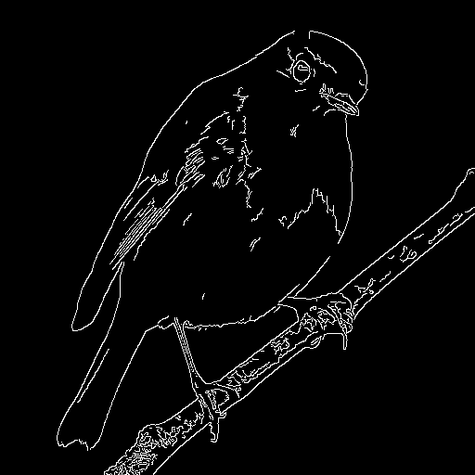

**Figure 3**: **Snapshot of the Loading the model to extract poses**

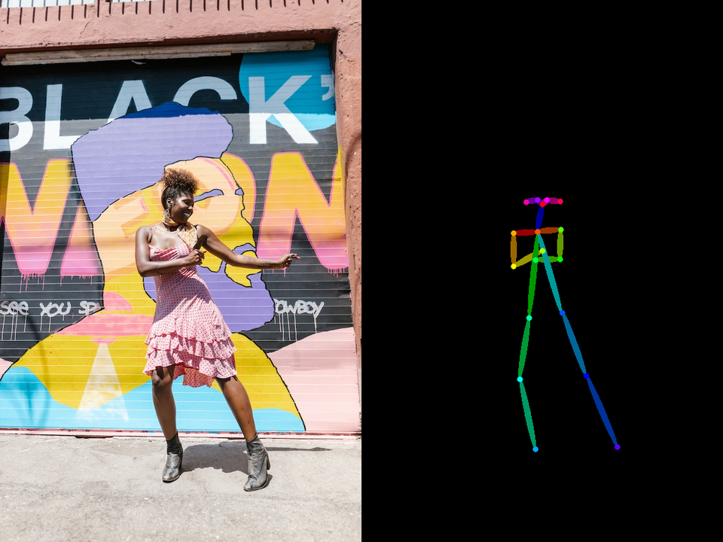

**figure 4**: **Snapshot of the Loading the ControlNet model**

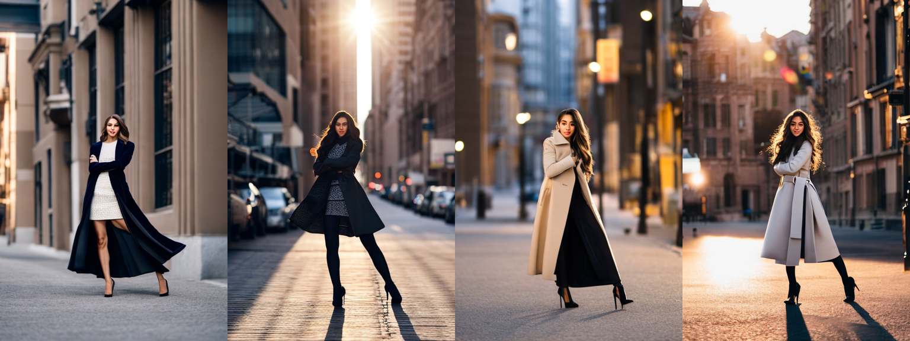

**figure 5**: **Snapshot of the Generating images using poses**

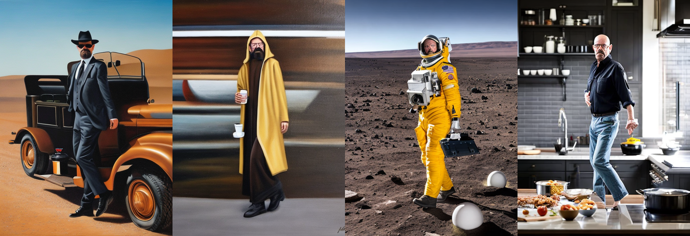

* 1. **GitHub Link for Code:**

https://github.com/Jashu-827/image_generation/tree/main

**CHAPTER 5**

**Discussion and Conclusion**

* 1. **Future Work:**

**Although the current work explored the integration of Stable Diffusion with Comfy UI to improve accessibility and ease the process of AI image generation for non-expert users, there are many areas where further improvements can be made to further optimize the system and address the challenges that have not been solved yet:**

* **Optimization of the User Interface (UI) and Accessibility:**

**Although Comfy UI makes it easier to interact with Stable Diffusion, there is always room for improvement. Future work may involve making the interface even more intuitive, such as by including advanced features like voice commands or real-time image previews as users input their prompts. Multilingual support could also be added to make the tool accessible to a global audience.**

* **More Customization Options**

**Future versions of the system can provide more refined user customization, like changing the resolution of generated images, setting the creativity level of AI outputs (for example, through temperature settings), or allowing users to fine-tune generated images right in the interface.**

* **Faster Generation of Images:**

**Despite the usage of GPUs, the generation of images can be slow, depending on the desired resolution. There is always the possibility to improve the algorithm, or even utilize more powerful hardware, such as multi-GPU setups or cloud-based solutions.**

* **Ethical and Bias Mitigation:**

**Reducing bias in the AI-generated content should also be a focus for future work. During training, the model may have used biased or problematic images, which are likely to emerge in the generated outputs. The future research could help identify and mitigate biases in the generated images, enforce filters, or engage more diverse and ethically sourced datasets.**

* **Integration with Other AI Tools**

**The future work avenue also lies in the integration of Stable Diffusion and Comfy UI with other AI tools, like text-to-speech or video generation systems, to create a more holistic and robust creative toolkit. This will enable users to generate not only images but also animated content, further extending the capabilities of AI in creative industries.**

* **Cloud-Based Deployment:**

**It might be possible to move the system to a cloud-based platform that would enable users to generate images without having high-performance local hardware. In other words, users with lower powered computers can generate high-quality images remotely from the cloud.**

* **Advanced Model Variants**

**Examining future models that might be able to work together with Stable Diffusion to produce more specialized forms of images such as 3D renders, stylized art, or photorealistic portraits can expand use cases for AI-generated content into a wide creative field.**

* 1. **Conclusion:**

**This project explores the transformative potential of AI-driven image generation, particularly in the context of Stable Diffusion and Comfy UI. It aims to make text-to-image models accessible to non-technical users by combining the advanced capabilities of Stable Diffusion with a user-friendly interface. Powerful generative models can be used by a broader audience to create high-quality images with minimal technical expertise.**

**The main strength of this project is its emphasis on usability and accessibility. There have been various AI image generation tools available over the years, but their complexity has usually hindered their widespread adoption. The project bridges this gap by making the interaction between the user and the model very simple, which allows users with diverse backgrounds to interact with state-of-the-art AI technology. The system designed in this thesis can have major implications across the board, from art and design to marketing and education.**

**Even though the current system has proven to be a success, challenges still remain. Some of these challenges include usability enhancement, acceleration of image generation, and the ethics of AI practices. However, the results of this project give a strong basis for further work on these tools and expanding their reach.**

**In conclusion, this project contributes to the growing field of AI-driven creative technologies and brings out the significance of making such technologies accessible and usable for everyone. The applications of AI image generation are so vast that when these tools become more user-friendly, they will open new doors for creativity and innovation.**

**REFERENCES**

1. Ming-Hsuan Yang, David J. Kriegman, Narendra Ahuja, “Detecting Faces in Images: A Survey”, IEEE Transactions on Pattern Analysis and Machine Intelligence, Volume. 24, No. 1, 2002.